Supplementary Assignment

28-11-2019

Group 20:

Elliot Andrew Seymour, [elliots@kth.se](mailto:elliots@kth.se)

Melik Atabeyli, [atabeyli@kth.se](mailto:atabeyli@kth.se)

KTH, TCOMK, Information and Communication Technology, Year 3 students

**1. The Company: Ericsson**

**Hard Facts About Ericsson**

[1] Ericsson is a multinational telecommunications and networking company originally from Stockholm, Sweden. The company does offer many services such as: software and infrastructure in information and communications technology for telecommunications operators, IP networking equipment and traditional telecommunications, fixed and mobile broadband and many other ICT related global level services. [2] It was first founded in 1876 with the intention of working as a workshop that could repair telegraph instruments and undertake small mechanical engineering jobs. [3] Their first owners were Lars Magnus **Ericsson** and Carl Johan Andersson. [4] Ericsson is now operating in more than 105 countries all around the world with different technologies. [5] According to their 2018 annual report, they had around 95000 workers placed in different positions globally.

**Ericsson’s Business Idea**

Ericsson’s CEO Börje Ekholm states their vision as “Our purpose is to empower an intelligent, sustainable and connected world. For more than a century, we have been putting smart tools in the hands of people in every sector of our society, creating intelligent technologies that drive positive change. We remain committed to this effort, leaving no one behind.”

[6] Their main competitors are “Aviat Networks”, “Quortus”, “Advantel Networks” and “Fastmetrics”. They are overlapping in many production or ICT areas and therefore they have some small internal wars between them regarding customer interest. Even though these count as the main competitors, looking at the gross sales we can surely see that Ericsson’s gross is about many tens of billions while the competitor’s swivel around millions. So not even close on that matter.

**Organisational Design of Ericsson**

As a company with almost 100,000 employees and with operations in over 180 countries the organisational structure of the company may differ from country to country and team to team however, the overall structure when looking at the top of the business is a classic hierarchical structure which is typical and of such a large business. [7] The board of directors sit at the very top of the company which appoints a President/CEO, who is responsible for the day to day management of the company. Directly below the CEO is the executive team which is made up of heads of Business and Market areas as well as group functions. There are 4 business areas in Ericsson which are responsible for developing and maintaining products and services. Ericsson also has 5 market areas which are responsible for selling and delivering its products and services across different markets. Finally, the group functions which are responsible for leadership, development of group policies and directives as well as common group processes.

**Ericsson’s Primary Business Model**

[8] Ericsson has three revenue streams: the sale of products, services and finally, licenses. Ericsson products are their network solutions, it manufactures the technology and equipment required for a customer. [9] These products are tailor made per customer as they are very complex as their customers are often telecommunications companies that cover entire countries for example, Tele2 have used Ericsson to roll out a 5G network covering central Moscow. The value there for is created by using materials and labour to create equipment and selling them for profit.

Ericsson’s services are then related to the support of these products such as, installing and configuring the network for the customer as well as maintaining it and even designing how the network will be implemented before building it.

Finally, Ericsson creates value by patenting some of its technologies and charging customers a license fee in order to use these technologies. These often include software. Ericsson’s product makes up 50% of the sales, services 44% and finally, the licensing is just 6%.

**Make a financial analysis of the company**

* **Did your company make a profit or a loss according to the latest annual report?**

[5] In 2018 the company made a net loss of 6276 million SEK.

* **In which way has the profit or the loss affected the company’s equity?**

[5] The loss resulted in the company’s equity decreasing. Aside from the decrease due to net loss the total equity over 2018 fell from 97,571 million SEK to 87,770 million SEK.

**Calculate and comment/analyze the following financial key performance ratio:**

* **Use DuPont Chart to illustrate and calculate:**

**Profit Margin = 1.98**

**Capital Turnover rate = 0.256**

**Return on total capital (ROT) = 0.508%**

**Return on equity (ROE) = -7.1%**

**Equity ratio 1 & 2 = 34%**

**Acid test ratio = 1.189**

**Debt/Equity Ratio (D/E) = 32.7%**

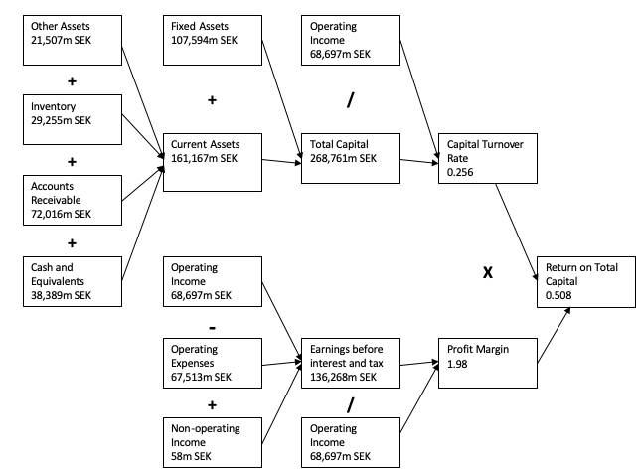

**Is this company your “dream company”? Why?**

I would personally define my dream company to be a company that is global and give opportunity to work all over the world, as well as a company that is always at the forefront of innovation. I would say that Ericson does meet this criterion. It operates in over 180 countries and from some research it seems that opportunities for employees to travel or even relocate is there.[7] In addition to this Ericsson is also a proven innovator, when it comes to the development of 5G technology in particular, Ericsson has been one of the first companies to roll out 5G networks with 23 live today in 14 different countries[10]. For these reasons I believe that Ericsson could be described as my dream company.

**2. SWOT-analysis**

**Strengths:**

**Product Innovation:** Ericsson has almost always been the leader when it comes to developing new products. It can be implementing or improving the existing line of products or entering new markets with new innovative products. **Distributed Network:** The marketing side of the company is also playing a vital role and is one of the most important strengths at this moment. Distributing over different networks to reach the mass of the potential buyers’ market. This network is developed in many complex ways so that Ericsson is dominant.

**Workforce:** The people that are working for Ericsson are definitely among the highly skilled ones when compared to all other global IT companies. This is the result of the company investing its time and resources into effective recruiting, team building and education/guiding alongside the workers careers.

**Weakness:**

**Investment in RnD:** This department of the company is definitely below when compared to the growing companies that are in the same industry. Even though the investments that are done to RnD research, they cannot keep up with the product results when compared in numerous technical areas. **Inventory:** Products and assets that are held in the inventory is a major drawback and a big weakness for the company. It is much higher when compared to the competitors. Keeping these assets on the book does affect the financial side of the company and does or will definitely impact the growth of Ericsson in the future.

**Opportunities:**

**Transportation:** Lowering the cost of moving items around the globe which also includes the shipment and deliverance of products directly to the customers.

**Market Development:** Infiltrating new markets will lead to greater competitiveness and make Ericsson more dominant.

**Threats:**

**Competitors:** Competitors may cause a threat with the development of some products and Ericsson should always be aware of this.

**Salary:** Raising the pay levels for some people in the production countries while keeping the production cost so low may stress on the profitability.

**Suggestions:**

There are definitely more than a thousand suggestions that can be made for a company this big and not all of it can be seen by us students. But what we can do is give some suggestions or so said our opinions based on the hard facts that we have learned from this course and read on webpages. Reducing the expenses on transportation as i mentioned in opportunities will mostly make the company more profitable. Making the investments they make on areas such as RnD much more efficient and strategically may help them. Always putting pressure on smaller competitive companies by dominating the market with or existing products/technology will mostly reduce the profitability of the competitors.

References:

[1] <https://en.wikipedia.org/wiki/Ericsson>

[2]<https://www.ericsson.com/en/about-us/history/shaping-history>

[3]<https://www.ericsson.com/en/about-us/history/company/ericsson-as-business/ownership-over-the-years>

[4]<https://www.ericsson.com/en/about-us/company-facts/ericsson-worldwide>

[5]<https://www.ericsson.com/assets/local/investors/documents/2018/ericsson-annual-report-2018-en.pdf>

[6]<https://craft.co/ericsson/competitors>

[7]<https://www.ericsson.com/en/about-us/corporate-governance/our-organization>

[8]<https://www.cleverism.com/company/ericsson/>

[9]<https://www.ericsson.com/en/news/2019/8/russias-first-5g-zone-deployed-in-moscow>

[10]<https://www.ericsson.com/en/5g>